#### LPAstart Lite.cpp

Step1 Create grildword maze vector:

Step2 set start and set goal:

Step3 create initialize function:

m_U.empty(); // Empty priority queue

m_pStart->rhs = 0; // rhs(Sstart)=0;

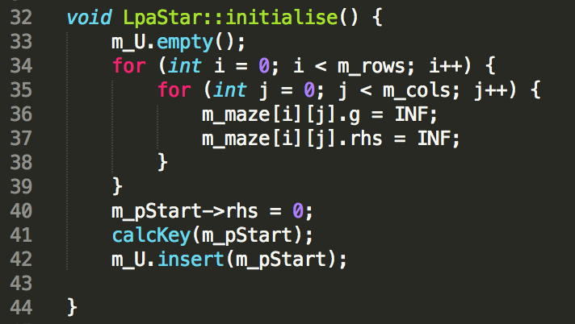

Step4 calculate heuristic value and update heuristic value:

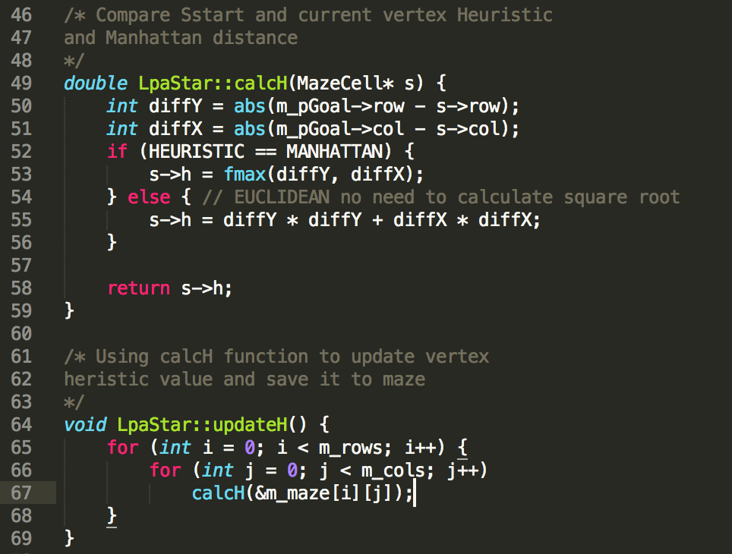

Step5 calculate Key value and update Key value:

*-ComputeShortestPath*

Step6 use D*Lite function lessThan() to compare the smallest key value.

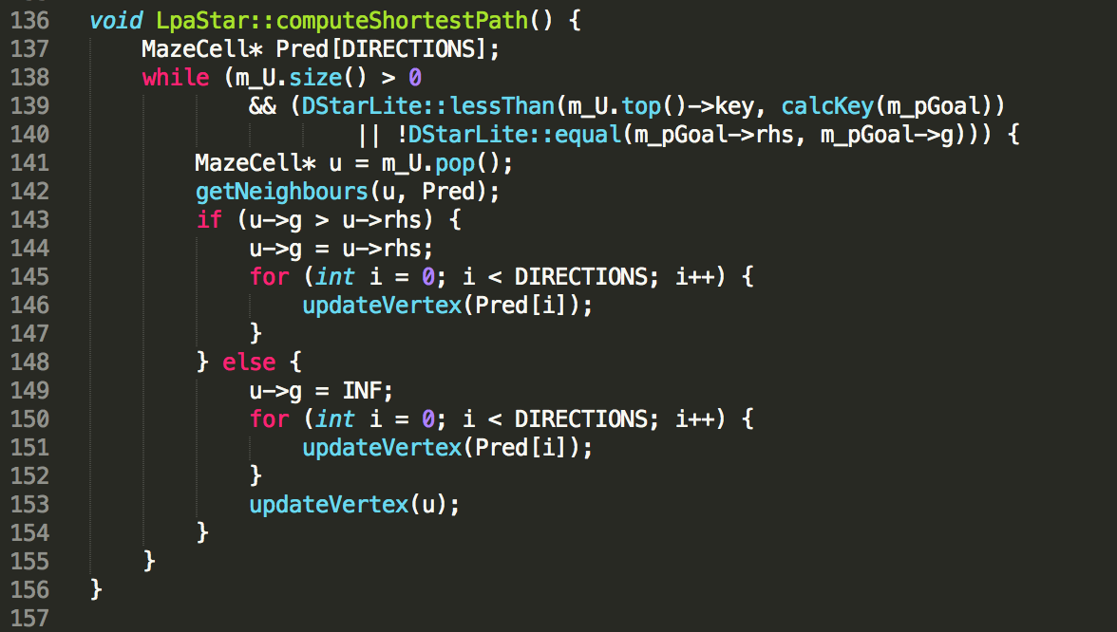

*-find path*

